3-tier architecture
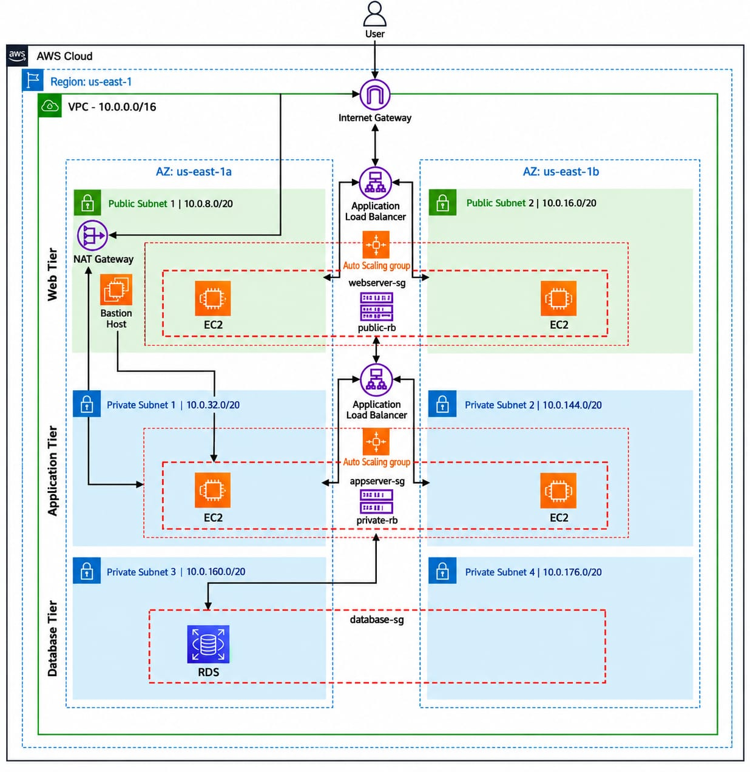
echo "<h1>Three-Tier Web Tier – us-east-1b</h1>" | sudo tee /var/www/html/index.html
echo "<h1>Three‑Tier private‑1b</h1>" | sudo tee /var/www/html/index.html

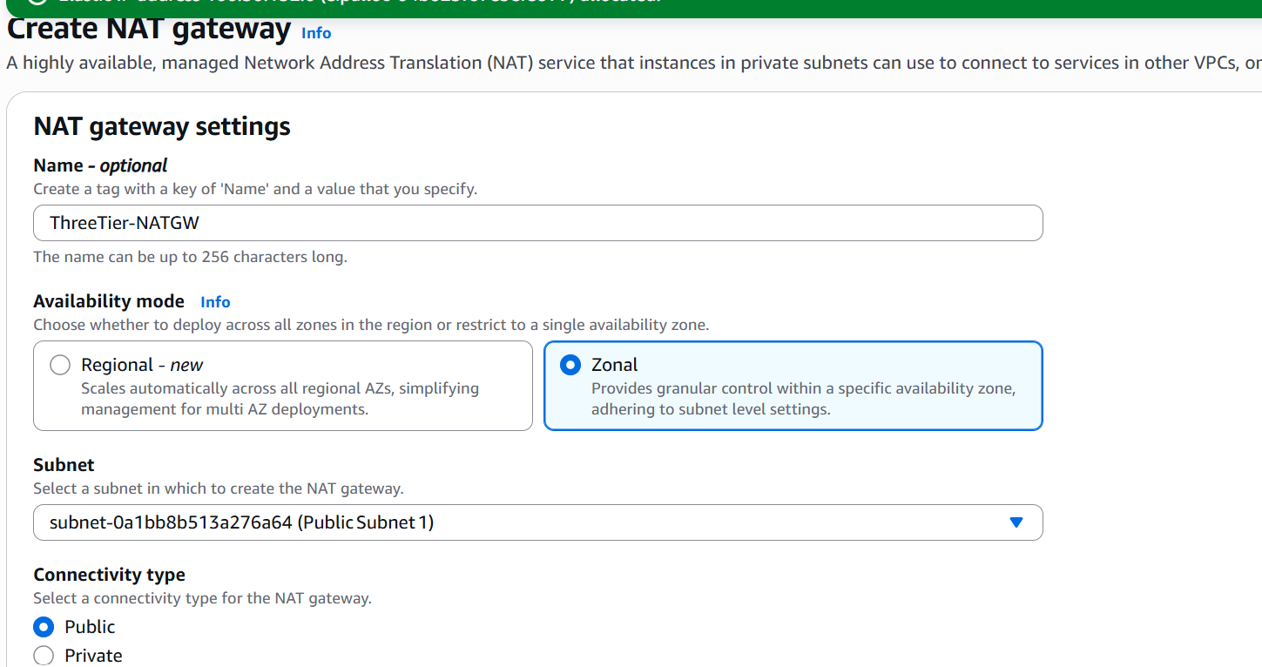
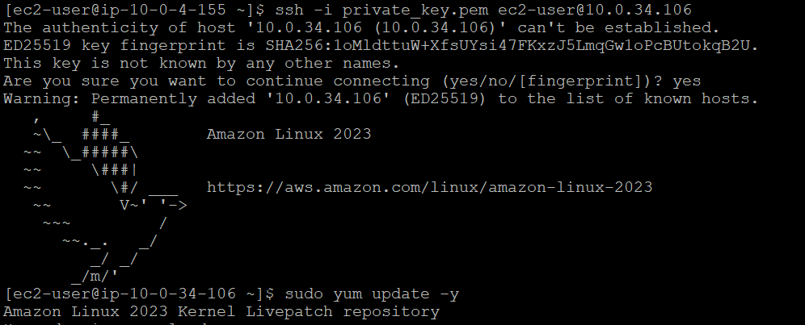
From bastian to private----
Ppk to pem convert----copy to bastain server—chmod 400 .pem---ssh -I that server as shoiwn in picture
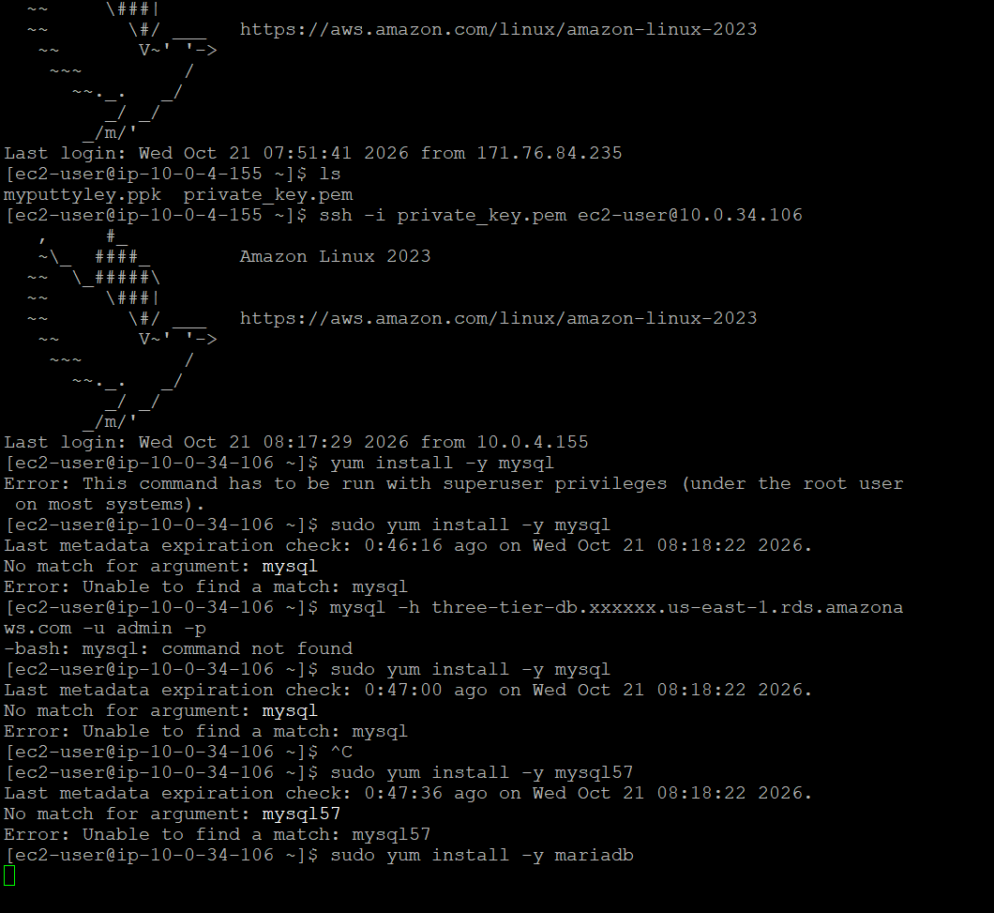

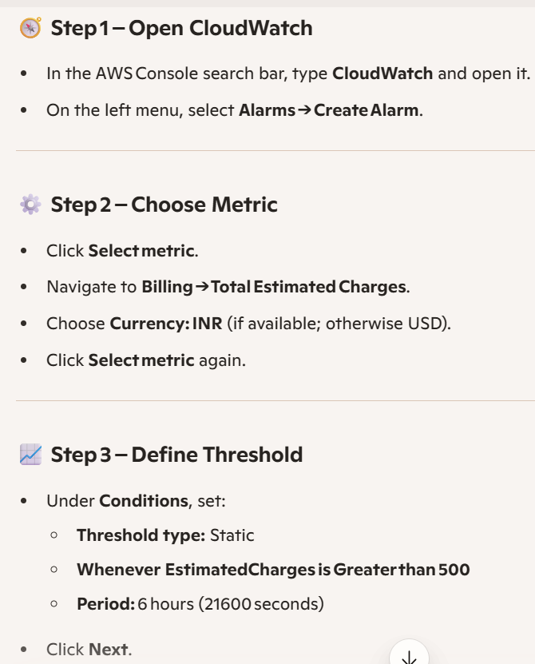

Billing alert:
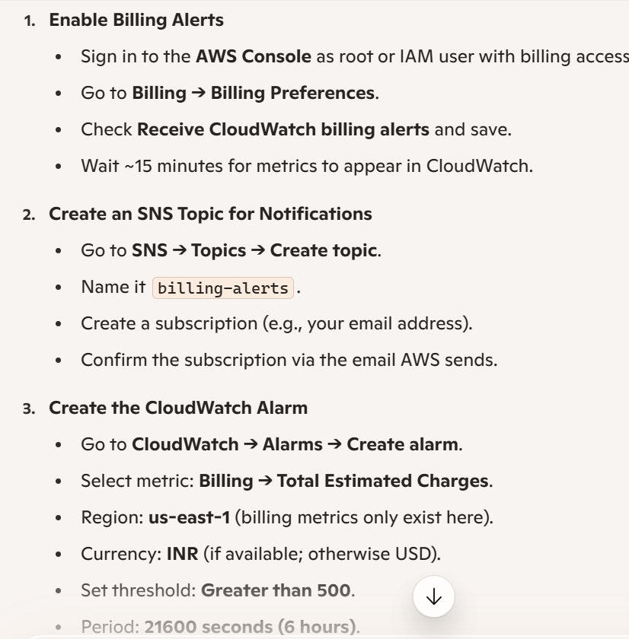
launch-wizard-2 –webserver sg
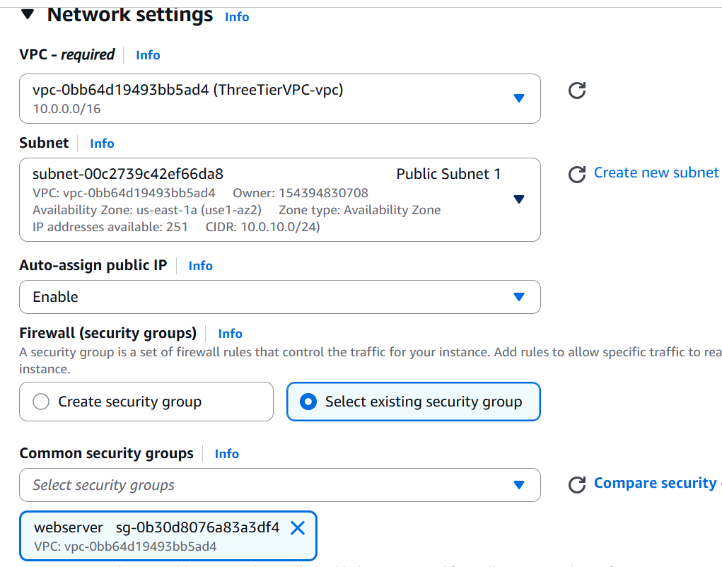
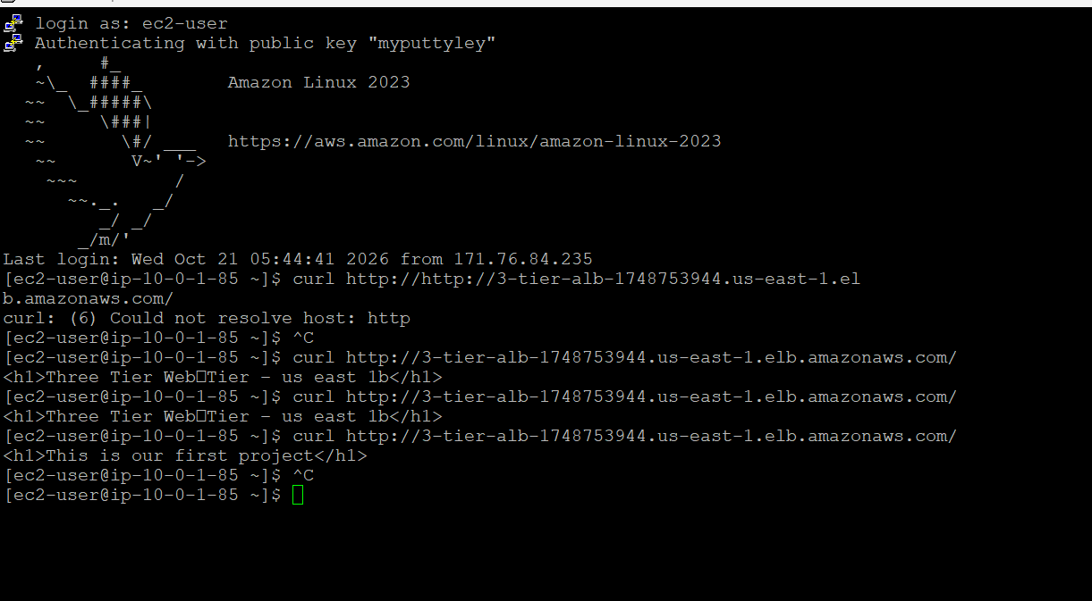
Download the client RPMs
wget https://dev.mysql.com/get/Downloads/MySQL-8.0/mysql-community-client-8.0.46-1.el9.x86_64.rpm
wget https://dev.mysql.com/get/Downloads/MySQL-8.0/mysql-community-common-8.0.46-1.el9.x86_64.rpm
wget https://dev.mysql.com/get/Downloads/MySQL-8.0/mysql-community-libs-8.0.46-1.el9.x86_64.rpm
wget https://dev.mysql.com/get/Downloads/MySQL-8.0/mysql-community-client-plugins-8.0.46-1.el9.x86_64.rpm

Install them manually (ignoring GPG check)
sudo dnf install -y mysql-community-common-8.0.46-1.el9.x86_64.rpm \
mysql-community-libs-8.0.46-1.el9.x86_64.rpm \
mysql-community-client-plugins-8.0.46-1.el9.x86_64.rpm \
mysql-community-client-8.0.46-1.el9.x86_64.rpm –nogpgcheck

Verify installation
mysql –version
Connect to RDS
mysql -h three-tier-db.c8b4ue04cm2f.us-east-1.rds.amazonaws.com -u admin -p
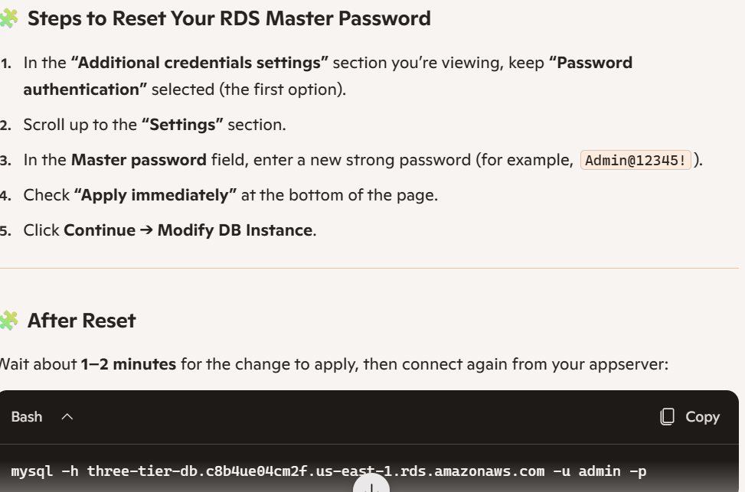

Written way with SS from scratch of 3-tier architechture.(21/10/2026)
VPC and Networking:
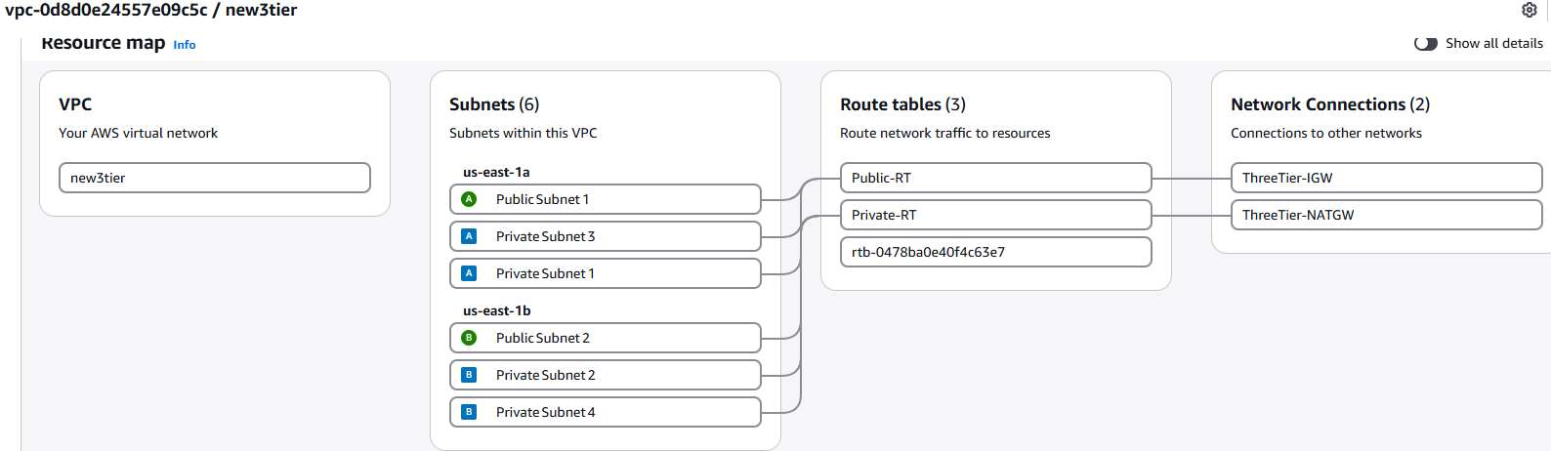
Create VPC → CIDR 10.0.0.0/16
Open VPC Console → click Create VPC.
- Name: new3tier
- IPv4 CIDR: 10.0.0.0/16
- Tenancy: Default → Create
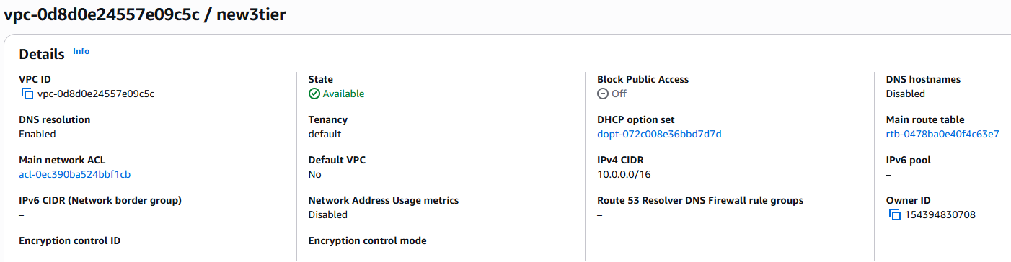

Create Subnets → six total (two public, four private)
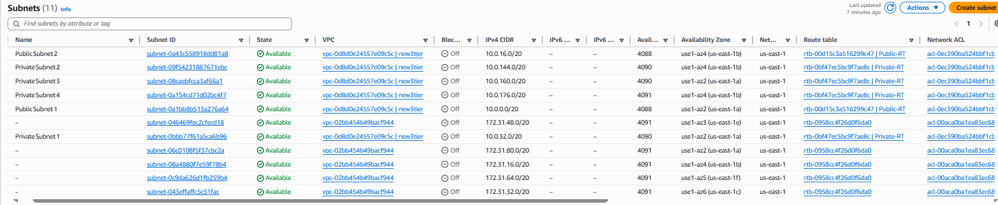
Create IGW, Attach Internet Gateway → link to your VPC
Create NAT Gateway → in Public Subnet 1 with Elastic IP
Click Allocate Elastic IP → AWS will assign a new public IP.
Select that Elastic IP.

Route Tables →
- Public RT: 0.0.0.0/0 → Internet Gateway.
- Private RT: 0.0.0.0/0 → NAT Gateway.
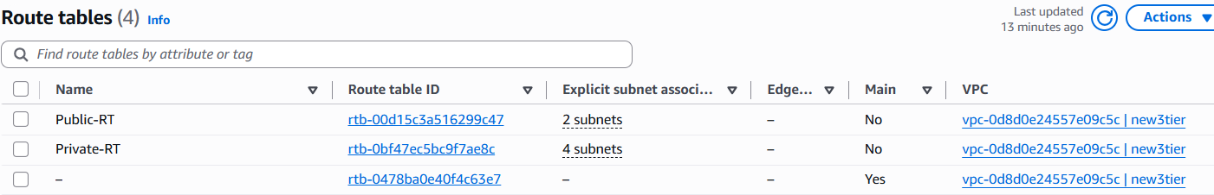
Go to Routes → Edit routes → Add route.
- Destination: 0.0.0.0/0
- Target: Internet Gateway (select the one attached to your VPC).
Save changes.
Go to Subnet associations → Edit subnet associations.
- Select Public Subnet 1 and Public Subnet 2
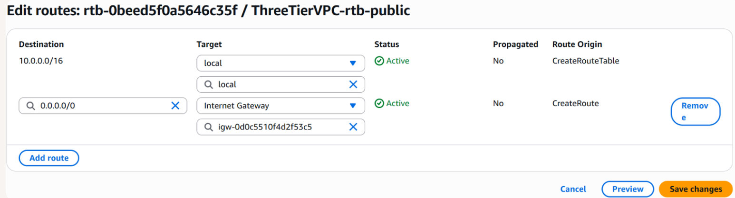
Open each private route table.
Go to Routes → Edit routes → Add route.
- Destination: 0.0.0.0/0
- Target: NAT Gateway (the one you created earlier).
Save changes.
Go to Subnet associations → Edit subnet associations.
- For private1-us-east-1a, select Private Subnet 1 and Private Subnet 3.
- For private2-us-east-1b, select Private Subnet 2 and Private Subnet 4

Web Tier
- Launch EC2 instances in Public Subnets 1 & 2.
Sg:
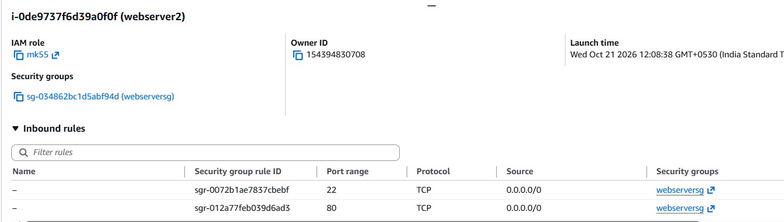
- Create Bastion Host in Public Subnet 1 for SSH access.
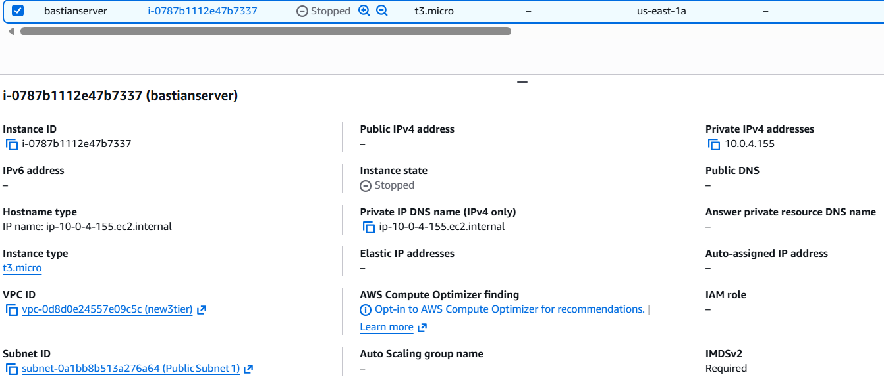
- Install web server (Apache or Nginx).
sudo yum update -y
sudo yum install -y httpd
sudo systemctl start httpd
sudo systemctl enable httpd
echo "<h1>Welcome to Three‑Tier Web Tier</h1>" | sudo tee /var/www/html/index.html
- Create Application Load Balancer (Internet-facing).
- Configure Target Group and Auto Scaling Group (webserver-sg).
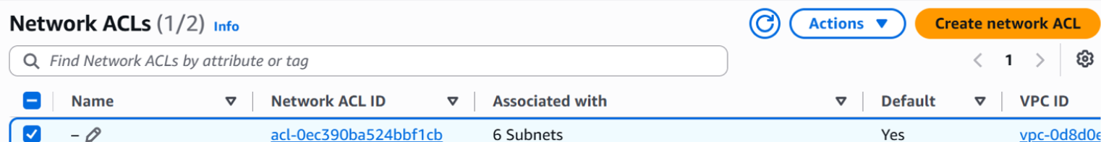
Load balancer:
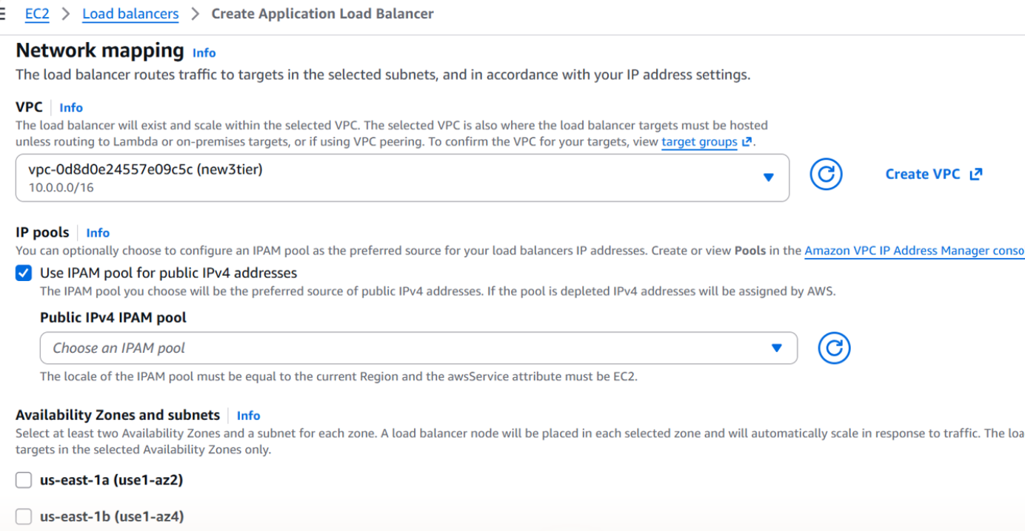
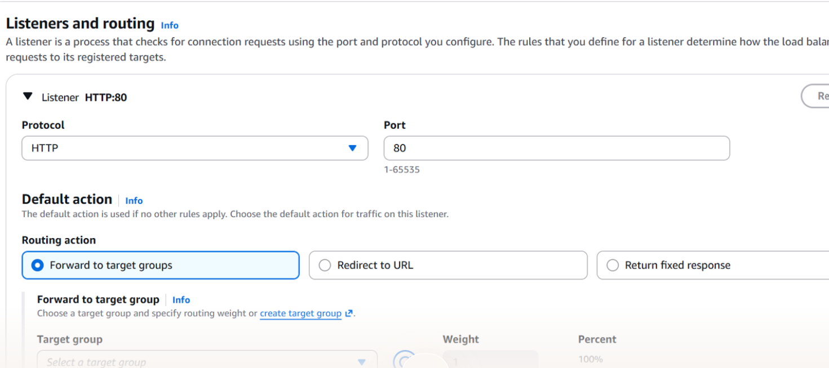
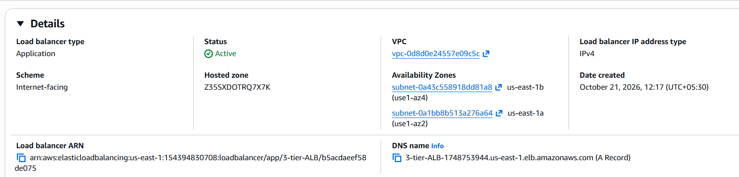
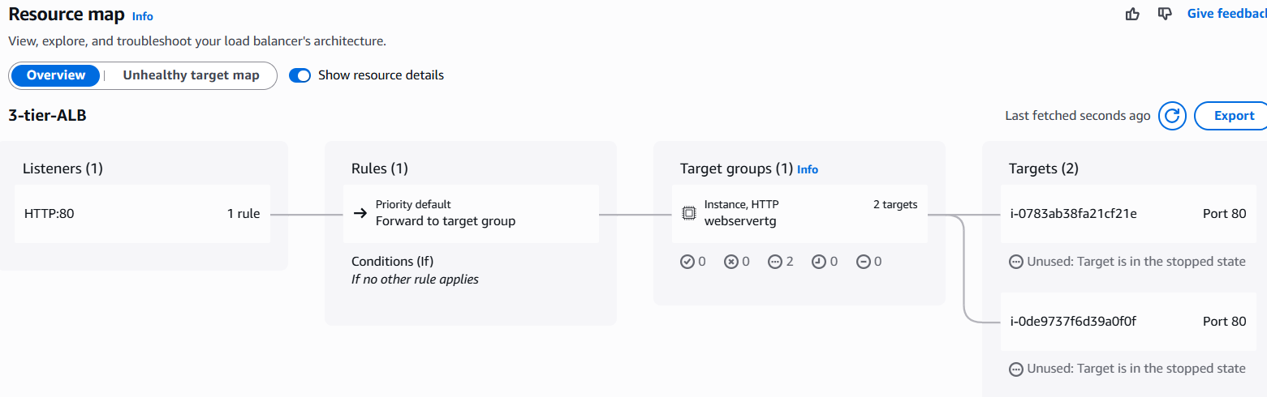
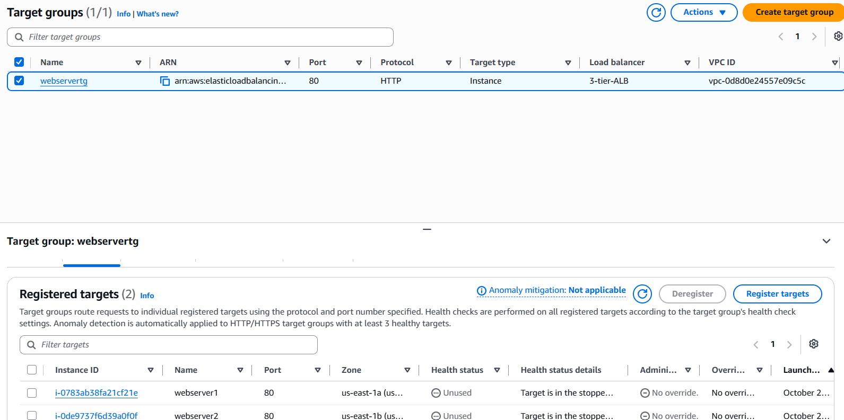
Application Tier
Sg:
EC2 → Security Groups → Create Security Group
- Name: appserver-sg
- VPC: ThreeTierVPC
- Inbound Rules:
  - Type: SSH (22) → Source: Your IP (for admin access)
  - Type: HTTP (80) → Source: webserver-sg (only web tier can talk to app tier)
- Outbound Rules: All traffic → 0.0.0.0/0

Bastion Host (Jump Server) :
- launch a small EC2 (e.g., t3.micro) in your public subnet.
- Connect to it via SSH using your key pair.
- From that bastion, SSH into the private EC2 using its private IP

- Launch EC2 instances in Private Subnets 1 & 2 install apache by connecting from bastian
Convert to .pem --- copy key to bastian server from winscp ----
chmod 400 puttykey.pem
ssh -i puttykey.pem ec2-user@10.0.40.75(this is private ip of app server)

- Create Internal Load Balancer (private-rb).
- Configure Auto Scaling Group (appserver-sg).
- Set Security Groups to allow traffic only from web tier.
Database Tier
- Create RDS instance (MySQL or PostgreSQL).
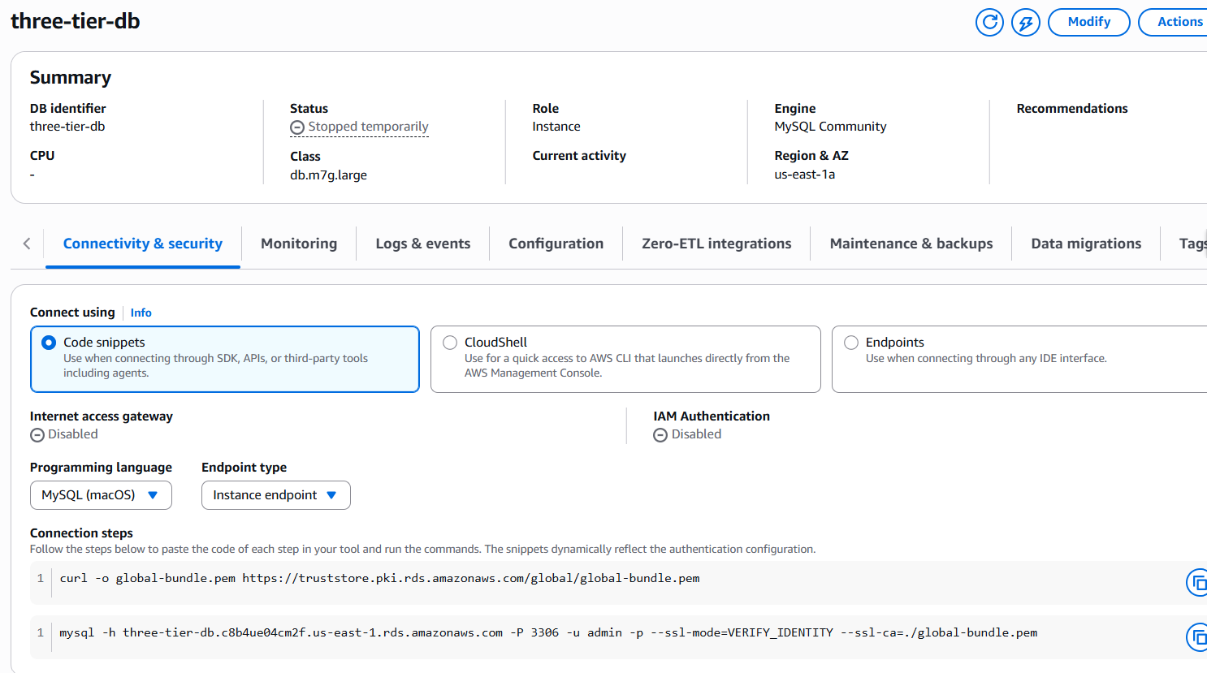
- Place in Private Subnets 3 & 4 with Multi-AZ enabled.
- Configure DB Subnet Group and database-sg to allow connections only from appserver-sg.
